Balanced and unbalanced Forces Worksheet OL
Name: _______________________________

Word Bank: (words may be used more than once)

balanced force unbalanced newton net force
force
- A _________________ is a push or a pull.
Net force
- ________________________ is the total of all forces acting on an object.

- When two forces working in opposite directions are not the same strength the forces are ________________.
unbalanced

- When two forces working in opposite directions are of the same strength the forces are ____________________.
balanced
forces
unbalanced
- _____________ forces result in motion of an object, but _______________ forces result in no motion.
newton
- The unit of measure for force is the _________________.

Circle the correct answer in each pair.
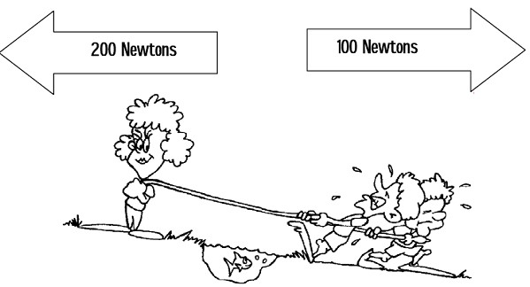

      - The forces shown above are PUSHING / PULLING forces.
      - The forces shown above are WORKING TOGETHER / OPPOSITE FORCES.
      - The forces are EQUAL / NOT EQUAL.
      - The forces DO / DO NOT balance each other.
      - The stronger force is pulling to the RIGHT / LEFT.
      - The weaker force is pulling to the RIGHT / LEFT.
      - Motion is to the RIGHT / LEFT.

