Friction: A Force That Opposes Motion – Guided Notes
- = A force that opposes between two surfaces that are in contact
- Friction happens because the of any object is rough (even those that feel smooth)
- The microscopic of one surface stick to the “valleys” of the other surface
- Factors that affect the amount of friction include: the pushing the surfaces together & the of the surfaces
- The Effect of Force on Friction
- If the force the surfaces together increases, the “mountains and valleys” come into closer contact, which the friction
- Objects that more have a greater downward than objects that weigh less, which also increases (harder “push” required to move the object)
- Changing how much the come into contact does not change the amount of friction
- The Effect of Surfaces on Friction
- Rough surfaces have more “mountains and valleys” than smooth surfaces, therefore more
- Ex. Trying to play hockey on vs. trying to play hockey on - The puck will slide easier on the because it is a smoother surface and has less

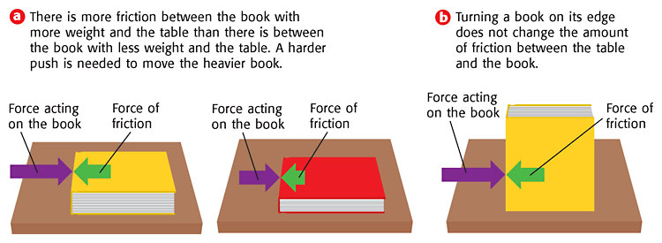

- Types of Friction
- Friction – friction between surfaces;
- Depends on how the surfaces move: or
- Usually the force of sliding kinetic friction is than the force of rolling kinetic friction; therefore, it is usually to move an object on wheels
- Ex. of kinetic friction: brakes on a bicycle, writing with a pencil
- Ex. of kinetic friction: anything that has wheels (bicycle, car, train, airplane, etc.)
- Friction – friction that acts on objects that are moving through and gases
- Ex. If you've ever tried to push your open hand through the in a tub or pool; you can feel the resistance of the water against your hand
- Ex. The skydiver is falling toward Earth with a parachute. Resistance of the against the parachute slows his descent.
- The faster or larger a moving object is, the greater the fluid friction resisting its motion; that's why there is greater air resistance against the parachute than the skydiver's body.
- Friction – when a force is applied to an object, but does not cause the object to move
- The force of static friction balances the force applied, so the object does not move
- Can be overcome by applying a large enough force
- as soon as the object begins to & kinetic friction takes over

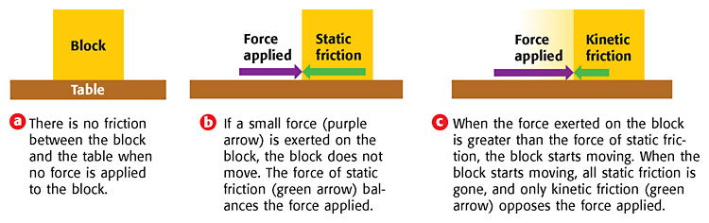
- Uses of Friction
- : Prevents slipping and sliding when walking, riding a bike, and driving a car; helps objects to slow down or stop moving; helps control motion; allows objects to move
- : Wears away at surfaces (Ex. Tires on a car need to be replaced periodically because friction between the road and tire wears down the tires); When surfaces rub together too much because of friction and they (Ex. Engine parts)
- Reducing Friction
- Applying (oil, wax, grease)
- a surface (making it smoother)
- Reduce the contact between the surfaces (ex. by adding )
- the forces acting on the surfaces (ex. less weight)

