Name: _____________________ Speed and Acceleration Review

Speed (S) or Velocity (V) | Acceleration or no Acceleration |  |  | Match the variables with quantities.
___ A bike goes 25 m/s toward main street.  ___ A person walks 4 mph.  ___ A plane flies 200 m/s.  ___ A bird flies 100 mph due south. | ____40 mph in straight line  ____ traveling in a circular path at a constant 15mph  ____changing speed from 150mph to 60mph  ____ a plane flying north at 135mph turns and flies east |  |  | - a = _________  - S = _________  - V= _________  - D = _________  - T= _________ | 23 sec  3 m/s²  23 meters/sec  23 meters  23 mph north
A person starts running from and travels 20meters north then travels south 10 meters.  What is the distance traveled? _______  What is the displacement? ________ |  | What is the speed of a beetle that travels 140 centimeters in 30 seconds? ___________________
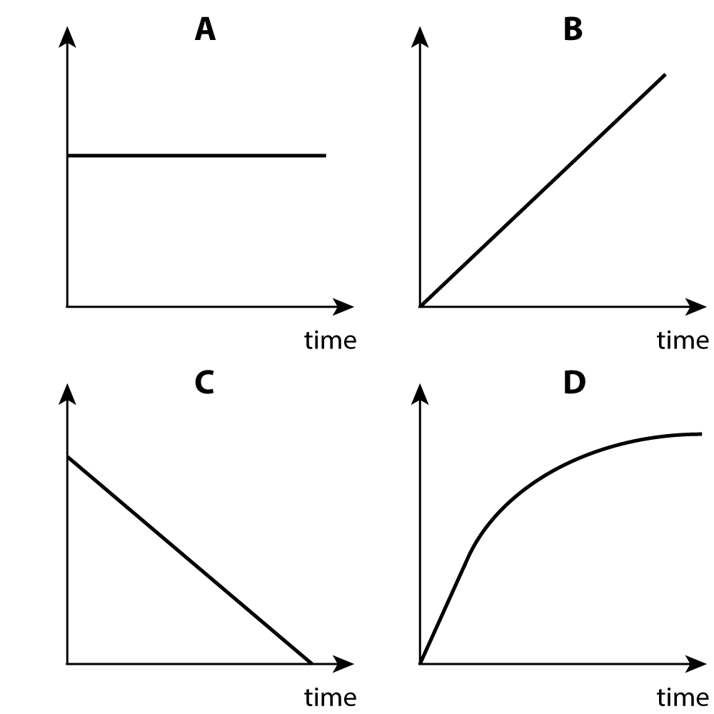  Distance  Distance  Distance |  | Use the time distance graphs to answer the following questions.  Which graph represents an object moving at a constant speed away from the reference point? ___________  Which graph shows an object at rest? _________  Which graph shows an object moving at a constant speed back towards the reference point. ______________  Explain what type of motion is happening in graph D. ___________________________________________________  ____________________________________________________
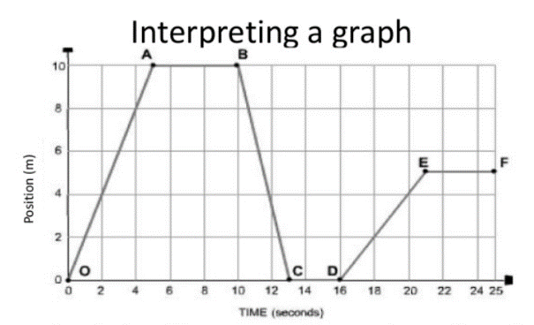 |  |  | Which line segments show the object at rest? ____________________________________  At what point on the graph does the object 1st change direction?  ______  What is the total distance the object traveled? _____________  When was the object traveling faster, between 0-A or between D-E? __________How do you know? ____________________________
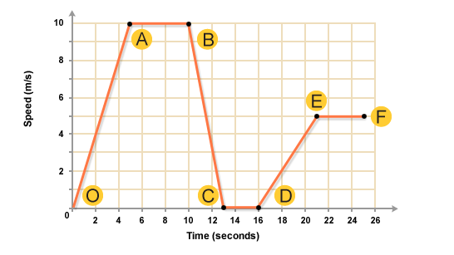
Use the graph to the right to answer the following questions.
Which segment shows the object at rest? ____________

Describe the motion between points 0-A?
_________________________________________________

Describe the motion between points B—C?
_________________________________________________

Describe the motion between points E-F?
_________________________________________________

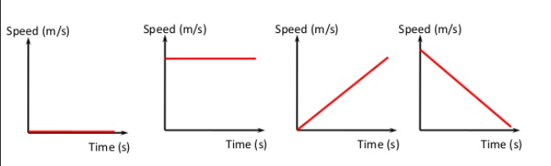___ ___ shows object with positive acceleration
4
3
2
____shows object at rest
___ shows object at a constant speed
____shows object with negative acceleration
1

