Forces Guided Notes
What is a force?
- A ___________________ or _____________________
- Changes the ____________________ of all objects
- Anytime you see something moving, you can be sure that a _______________ created its motion
Forces are Everywhere
- Without forces, sports, dancing, driving…basically everything would be impossible
- Some forces, like _______________, are present when things are not moving
Types of Forces
- ____________________ force: created between two touching objects (holding a pencil, hugging someone, etc.)
- ____________________ force: force that can be exerted on an object without contact (think “fields”)
Types of Forces
- ___________________: force of attraction between two objects, Earth’s gravity pulls on all objects (_______________ force)
- ___________________: a force that resists motion between two surfaces that are pressed together (_______________ force)
- _____________ _______________: magnetism (distant), tension (contact), electrostatic (distant), support (contact)
Types of Forces
- Looking at this picture again, there is another force present… what is it?
What is holding the skater up? The ground!
- It is called the ___________________ force.
- It is the support force exerted upon an object which is in contact with another stable object.
- For example, if a book is resting upon a surface, then the surface is exerting an upward force upon the book in order to support the weight of the book
Units
- The unit for force is ___________________. Abbreviated ___________
- 1 newton – accelerating a 1kg object at 1m/s each second
- 1 pound = _______________ newtons
Forces have ________________ & ______________
- Like velocity, force is a ________________.
- That means it has ___________ (magnitude) & direction.
Magnitude = _________________ or _________________ of the force – it is measured in Newtons
Force Vectors
- A vector is an _________________ used to show the ____________________ & ___________ of a force.
- The arrow ________________ in the ____________________ of the force.
- The ______________ or _____________________ of the arrow represents the ________ or ________________ of the force.

Force Vector Examples
- A ________________ force of 5 N would have a _______________, _________________ arrow.
- A ________________ force of 500 N would have either a ___________ arrow or a _______________ one.
Combining Forces
- Usually, _________________________ force is exerted on an object at the same time.
- The ________ of all forces acting on an object is called the _________ force.
- You need to look at the net force in order to figure out if or how an object will __________________.
Balanced Forces
- Net force = ____________
- ______ change in motion
- (object is not moving)
- List 3 examples of balanced forces: paper on desk, you in the chair, flag not moving
Unbalanced Forces
- There is a ___________ force acting on an object
- Causes a change in motion
- Possible to add the forces together to find the size and direction of the net force
Unbalanced Forces
- If the forces are moving in the ____________ direction, ___________ the forces.
- Example:
Girl pushes 25 N to the right, Boy pulls 20 N to the right, Net Force = 45 N to the right
Unbalanced Forces
- If the forces are moving in ______________ directions, _______________ the forces.
- Example:
Dog #1 pulls 10 N to the left, Dog #2 pull 12 N to the right, Net Force = 2 N to the right
You Try It: Calculating Net Force
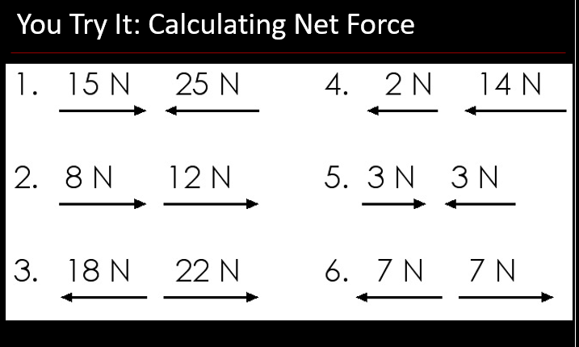
Sample Test Question #1
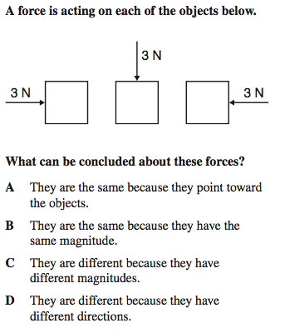
Sample Test Question #2
