Name__________________

Learning Objectives: Students will be able to
- Predict how forces can change motion.
- Provide reasoning and evidence to explain motion changing or not.

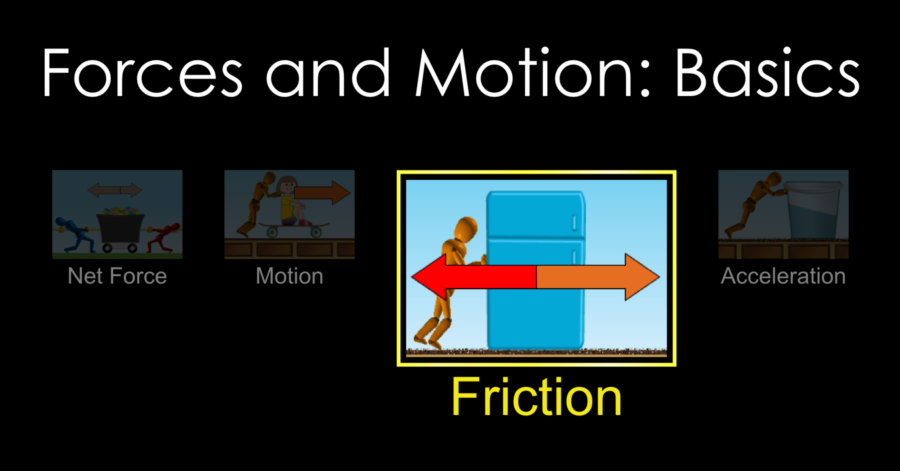
- Open the Forces and Motion Basics simulation and play with the Friction screen for a few minutes.

- Imagine that your friend, Sam is trying to move a box.
  - Using what you learned by exploring, try drawing arrows to predict what might happen in the pictures below. (Try this part without using the simulation.)

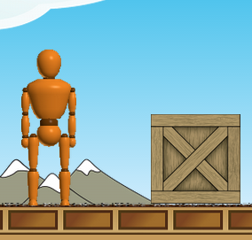 | 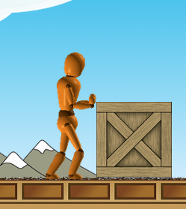 | 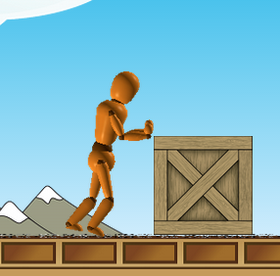
Sam not pushing | Sam pushing but box not moving | Sam pushing and box moving

  - Check your sketches using the sim and make corrections if needed. List any new ideas you discovered.

  - What do you notice about the similarities and differences between the Applied Force arrow and the Friction Force arrows in each situation?

- How can you make the Friction Force more? What shows you that the force is more?

- In your own words,
  - describe Friction Force.

  - describe Applied Force.

- Have Sam try to move the refrigerator. What’s different from pushing the box?

  - In the table, draw the Sum of Forces arrow for the different cases:

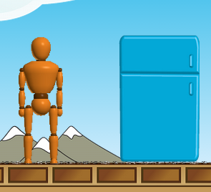 | 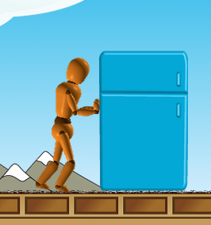 | 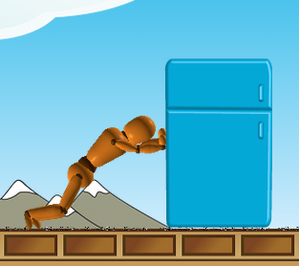
Sam not pushing | Sam pushing but refrigerator not moving | Sam pushing and refrigerator moving

  - Were you able to move the refrigerator? If not, what would you have to change? Describe what you did.

- Try pushing other things; you can even stack them. What have you discovered?

- Can you find different ways to make the Sum of Forces arrow change?
  - List at least three:

  - In your own words, what is Net Force?

- What are some ways you can change the speed?

- Using your answers to Question #8, what general statement can you make about the relationship between net force and how fast an object changes its speed.

